Install / Verify
- VS Code - https://code.visualstudio.com/download
- Git - https://git-scm.com/install/windows
- Node.js - https://nodejs.org/en/download
- Expo - https://docs.expo.dev/get-started/create-a-project/
- Expo Go - https://expo.dev/go
- GitHub Copilot extension (login required) - https://github.com/signup

node -v
npm -v
git –version

npx create-expo-app portfolio-app
cd portfolio-app
npm start

git init
git add .
git commit -m "Initial Expo portfolio app using Copilot"

git remote add origin <repo-url>
git push -u origin main

NOTES

git –-version at command prompt

go to folder -> left click -> open terminal

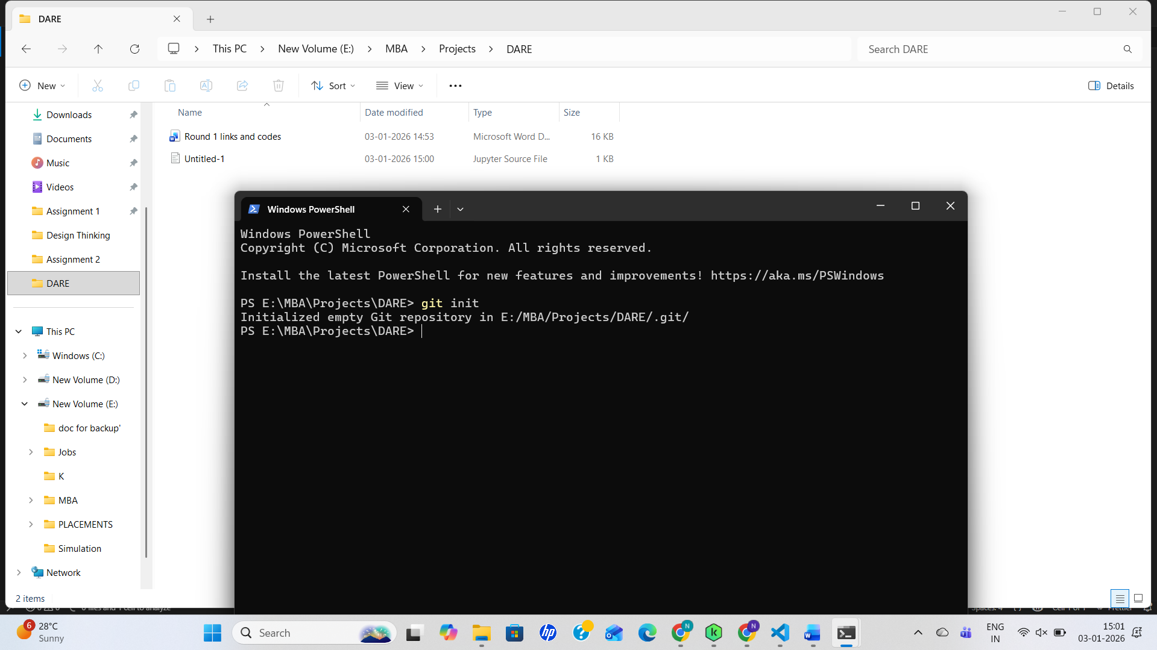

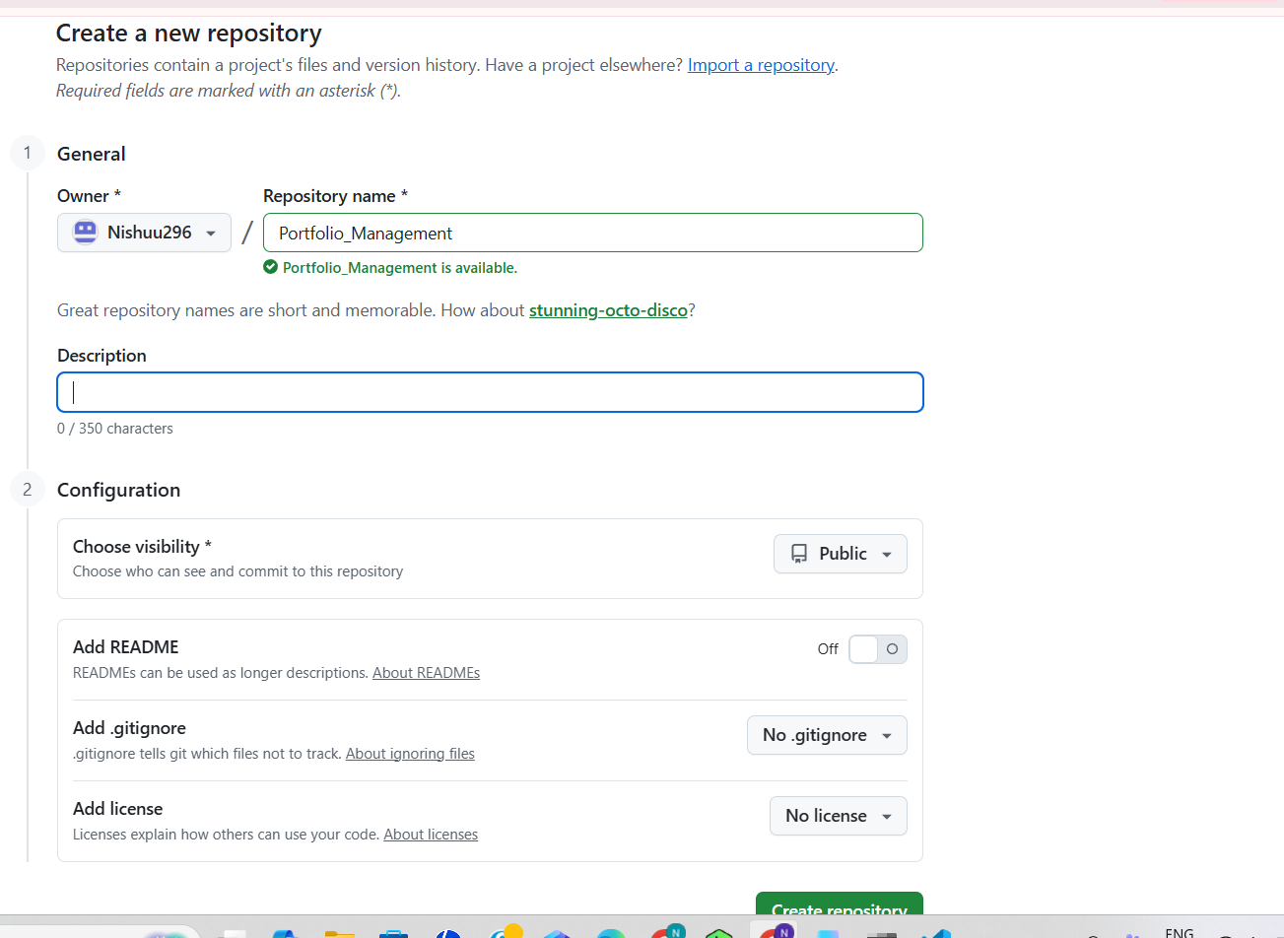

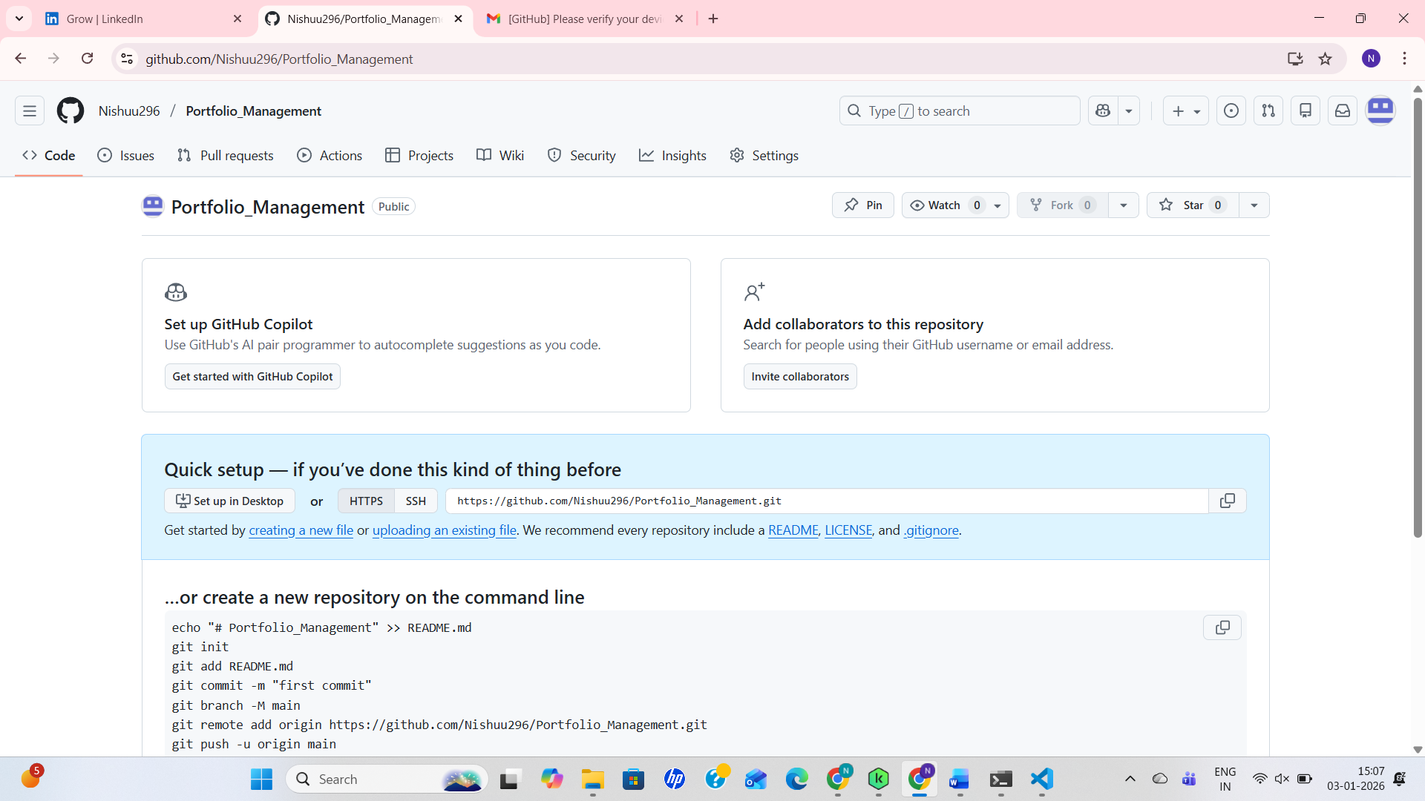

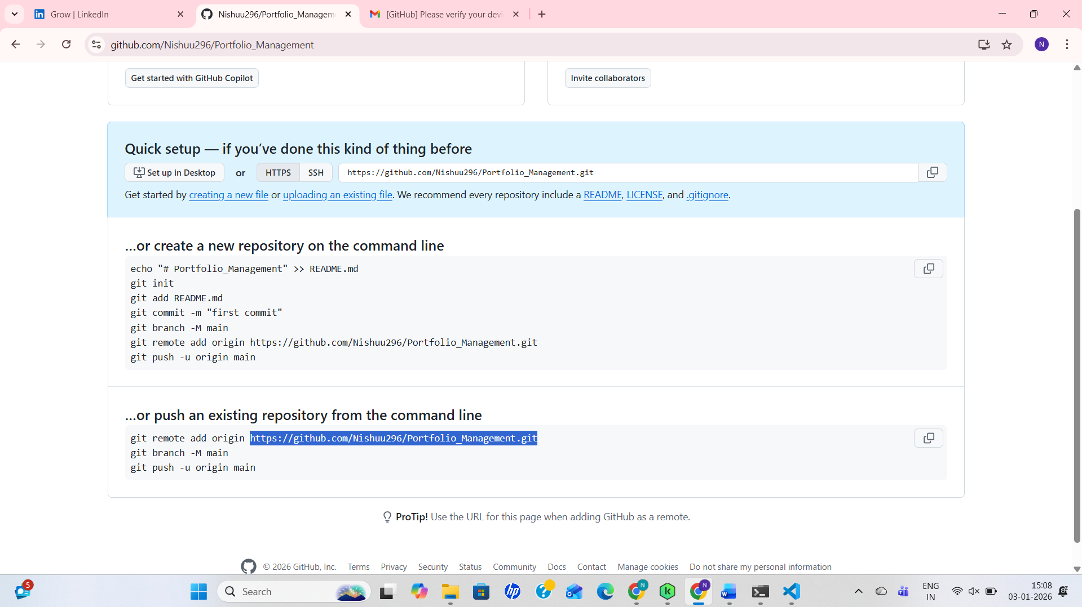
Link to connect

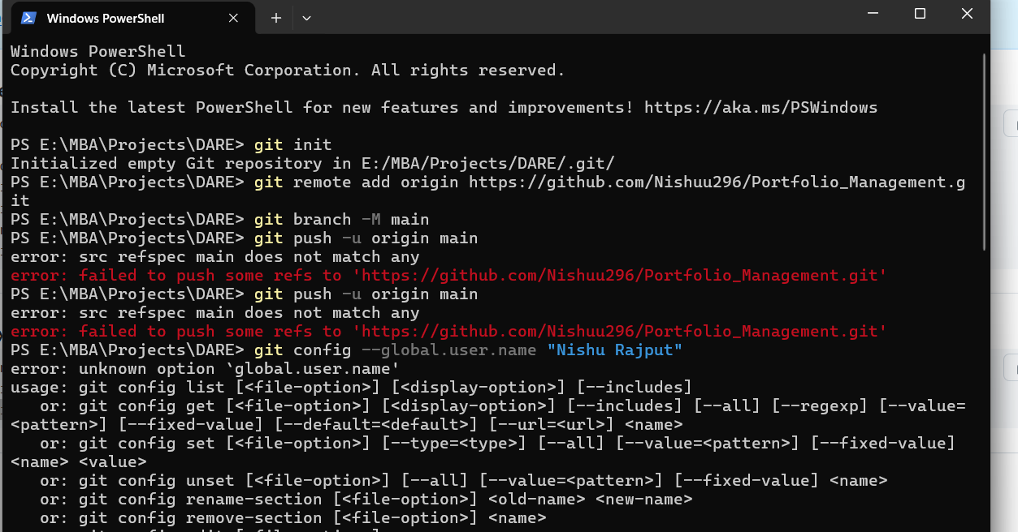
Set git username and email globally.
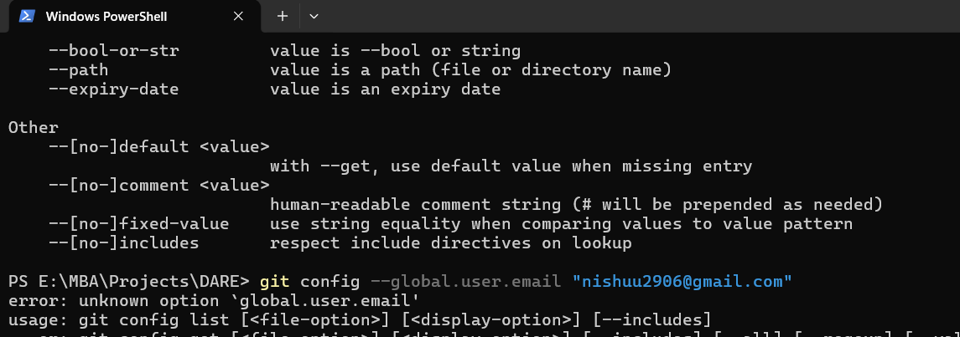

git config --list –global : to check

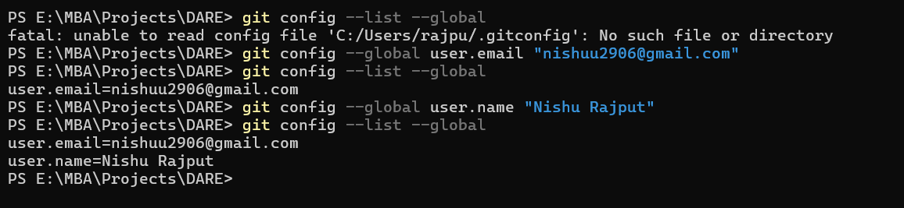

Git push -u origin main

Git add

Git commit -m “first commit”

Git push origin main

